 | INFRASURE 2027  Infrastructure Sustainability and Resilience Forum  Platinum Jubilee Celebrations – Department of Civil Engineering  22–24 January 2027 · IIT Kharagpur, India | 

Extended Abstract Title – Case as Shown, Times New Roman 14pt Bold
A.N. Author¹, B.N. Another² and C.N. Third¹
¹Department / Institute, City, Country
²Second Department / Institute, City, Country
E-mail: corresponding.author@institute.ac.in
(Presenting author's name should be underlined. Use superscript numerals to link each author to an affiliation, as shown above.)
Keywords: List 4–6 relevant keywords, separated by a comma and a space.

1. Introduction
State the problem, its significance to infrastructure sustainability and resilience, and the specific gap your work addresses. (Body Text, Times New Roman 10pt, single-spaced, fully justified.)

2. Methodology / Study Area
Briefly describe the data, methods, models, or experimental set-up used. Keep this section concise — the extended abstract is a summary, not the full paper. Where relevant, present key equations using an equation editor (or clearly formatted text), numbered consecutively with the number right-aligned, as shown below (style Equation, 10pt).
IVI = ( w₁x₁ + w₂x₂ + … + w_{n}x_{n} ) / n | (1)
where IVI is the infrastructure vulnerability index, wᵢ is the weight assigned to indicator i, xᵢ is its normalised value, and n is the total number of indicators (always define symbols immediately after the equation, as here). Refer to the equation in text as Eq. (1).
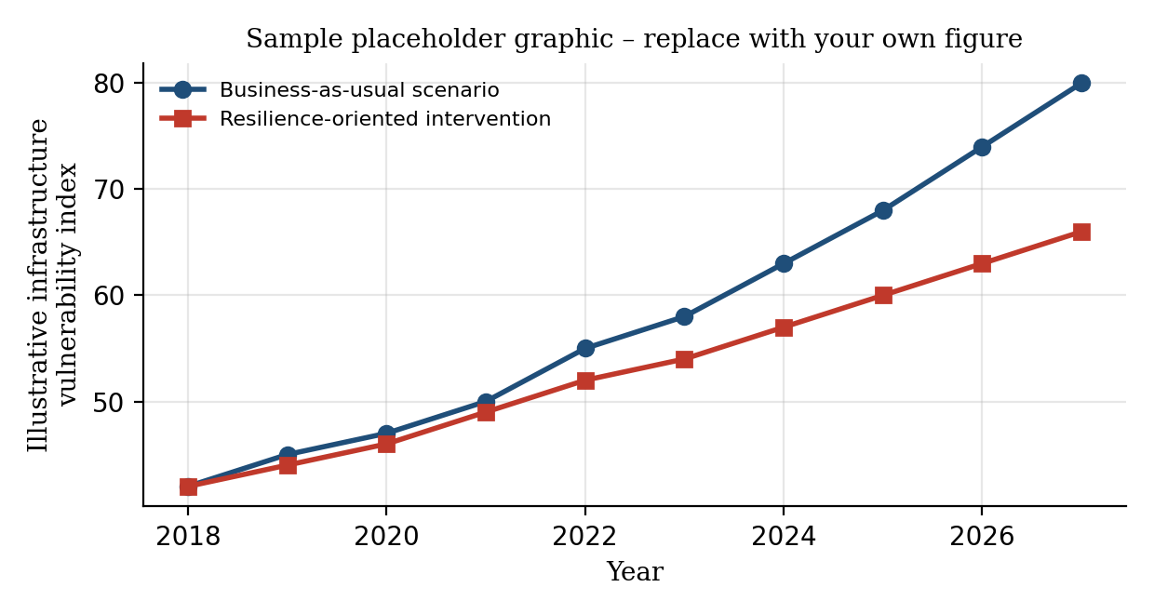
Figure 1. Replace with your own graphic (chart, map, schematic, or photograph). Use PDF, PNG, or JPEG; minimum 300 dpi; centre the figure and its caption (style Caption).

3. Results and Discussion
Summarise the principal findings and their interpretation. A single supporting table may be included if needed, labelled and captioned above the table (style Table caption), as shown below.
Table 1. Replace with your own data. Caption is placed above the table, centred (style Table caption).
Indicator | Weight (wᵢ) | Data source
Structural condition | 0.35 | Field survey
Exposure to hazard | 0.40 | Hazard map / GIS
Redundancy | 0.25 | Network model

4. Conclusions
State the main conclusions and, where relevant, their practical implications for sustainable and resilient infrastructure.

5. Acknowledgements
Optional. Acknowledge funding sources and contributors who are not authors. Delete this section if not applicable.

6. AI Tools Acknowledgement
If any generative AI or AI-assisted technology (e.g., for drafting, language editing, code generation, data analysis, or image/figure creation) was used in preparing this abstract, briefly state which tool(s) were used and for what purpose. If no such tools were used, state ‘Not applicable – no AI tools were used in the preparation of this work.’
AI tools may not be listed as an author or co-author, and authors remain fully responsible for the accuracy, originality, and integrity of the content, including any text, data, or analysis produced with AI assistance.

7. References
Use ASCE journal reference format. In-text: Barker (1992) or (Barker 1992); two authors – Jones and Smith (1998); three or more – Feugard et al. (1994). List references alphabetically by first author's surname (style References, 9pt).
King, S., and Delatte, N.J. (2004). “Collapse of 2000 Commonwealth Avenue: Punching shear case study.” J. Perf. Constr. Facil., 18(1), 54–61.
Fwa, T.F., Liu, S.B., and Teng, K.J. (2022). “Airport pavement condition rating and maintenance-needs assessment using fuzzy logic.” Proc., Infrastructure Sustainability and Resilience Forum, IIT Kharagpur, India, 29–38.
Smith, N.J., and Jones, M. (2019). A Companion Guide to Resilient Infrastructure, Academic Press, New Delhi.

Formatting Instructions (delete this page before submission)
1. Page Limit
The extended abstract — including the title block, text, one graphic, one table, and references — must not exceed TWO A4 pages. Abstracts exceeding this limit will be returned for revision before review.
2. Margins and Page Layout
Set out your abstract on A4 size paper with 25 mm (1 in) margins on all sides, as given below. Text should be single-spaced and fully justified, using the Body Text style (Times New Roman, 10pt).
Margin | Metric | Imperial
Left | 25 mm | 1 in
Right | 25 mm | 1 in
Top and bottom | 25 mm | 1 in
3. Guidelines for Figures
Graphics such as charts, photographs, maps, and line drawings should be in electronic form and embedded directly in the document (not linked). Use PDF, PNG, or JPEG files at a minimum resolution of 300 dpi, as these are more compact than bitmap formats such as BMP. Use colour where it aids interpretation. Number figures consecutively (Figure 1, Figure 2, …) with a short caption below each, in 9-point italic Times New Roman (style Caption). Centre both the figure and its caption. Only one figure is required for the extended abstract; additional figures may be included only if the two-page limit permits.
4. Guidelines for Tables
Tables should be labelled Table 1, Table 2, etc., with the caption placed ABOVE the table (unlike figure captions, which go below), using the Table caption style. Centre tables and captions on the page, and refer to each table in the text before it appears.
5. Equations
Lay out mathematical equations using an equation editor, or clearly formatted text as in the example on page 1, and number them consecutively with the equation number right-aligned in parentheses. Leave a blank line above and below each equation to separate it from the surrounding text. Define all symbols immediately after the equation, and refer to equations in the text as, for example, ‘from Eq. (1)’.
6. Units
Express all quantities in SI units (Système International). Equivalent ES (English System) units may be included in parentheses following the SI value where helpful to readers.
7. Headers, Footers and Page Numbers
DO NOT insert headers, footers, or page numbers — these will be applied uniformly when the abstract booklet is compiled. Avoid footnotes where possible; use parentheses within the text instead.
8. Bullets and Numbering
Use bullet points for unordered lists and numbered lists for sequential steps or ranked items; both should be indented consistently from the left margin, for example:
- Use bullet points when there is no inherent sequence.
- Keep bullet and numbered items indented and consistently styled.
9. AI Tools Acknowledgement
Every submission must include an AI Tools Acknowledgement (Section 6) disclosing any generative AI or AI-assisted tools used in preparing the text, analysis, or graphics, and their purpose. State ‘Not applicable’ if none were used. AI tools cannot be credited as an author, and authors are responsible for verifying all AI-assisted content.
10. File Naming and Submission
Save your file using the surname of the first author, e.g., AUTHOR_INFRASURE2027.docx, and submit through the conference portal.
Quick-reference: fonts and styles
Element | Font / size | Style
Title | Times New Roman, 14pt, Bold | Title
Author names | Times New Roman, 10pt | Author
Affiliation | Times New Roman, 9pt, Italic | Affiliation
Section heading | Times New Roman, 10pt, Bold | Heading 1 / 2
Body text | Times New Roman, 10pt | Body Text
Figure / table caption | Times New Roman, 9pt, Italic | Caption
References | Times New Roman, 9pt | References
Submissions that do not follow this template may not be accepted for review.

